МУНИЦИПАЛЬНОЕ ОБЩЕОБРАЗОВАТЕЛЬНОЕ УЧРЕЖДЕНИЕ

«КУКУЙСКИЙ ЦЕНТР ОБРАЗОВАНИЯ ИМЕНИ И.Ф. СЕБРОВОЙ»

ВЕНЕВСКОГО РАЙОНА ТУЛЬСКОЙ ОБЛАСТИ

**Разработка открытого урока**

**для 8 класса по теме**

**«Круглый стол «Общение»**

Подготовила

учитель английского языка

Титова Мария Васильевна

2024 год

**Конспект открытого урока английского языка в 8 классе**

**по теме «Круглый стол «Общение»**

**Дата проведения:** 24.09.2024 г.

**Класс:** 8

**Тема урока:** Круглый стол «Общение».

**УМК:** «Английский язык» Ваулина Ю.Е., Дули Д., Подоляко О.Е., Эванс В.

**Тип урока:** урок комплексного применения знаний.

**Цели урока:**

**Обучающие:** обобщающее повторение изученной тематической лексики в устной речи учащихся в процессе развития иноязычной коммуникативной компетенции по темам «Характер», «Общение».

**Развивающие:** - развивать навыки и умения во всех видах речевой деятельности; - развивать критическое мышление; - развивать внимание и познавательную активность.

**Воспитательные:** - воспитание культуры межличностного общения; - воспитание интереса к предмету, уважения к одноклассникам.

**Оборудование урока:** технические средства: ноутбук, проектор, интерактивная доска, документ-камера, аудиосопровождение; программное обеспечение: программа для создания интерактивной презентации Smart Notebook; раздаточный материал: карточки с заданиями для индивидуальной, парной и групповой работы.

**A round table “Socialising”**

**ХОД УРОКА**

1. **Организационный момент.**
2. **Teacher:** Good morning, children!

**Pupils:** Good morning, teacher,

**Teacher:** I am glad to see you.

**Pupils:** We are glad to see you, too!

**Teacher:** Sit down, please.

* Dear boys and girls, today we have many guests. They have come to see our lesson. Smile them and say “Good morning!”
* How are you today?
* Are you ready for the lesson?

**Ps:** Yes. We’re ready for the lesson.

* **T:** Olya, are you ready for the lesson?

**P1:** Yes, I am ready for the lesson. I have got a textbook, a workbook, an exercise-book, a record-book, a pencil-box with pens, pencils, a ruler, and a rubber.

1. **Определение темы урока.**

**T:** It’s time to start.Listen to some extracts describing one topic and try to say what we are going to speak about today. The pictures on the screen can also help you to make your decision.

**TEXTS**

|  |
| --- |
| Only fancy, how would we live if people all over the world don’t communicate with one another? Life would be dull and monotonous. Acquaintance plays a significant role for a society. If it were not for communication and dialogues between people, it is unlikely that we’d have friends, family and buddies. |
| Our speech and tongue – that is what helps us start a simple conversation with passers-by, fellow travelers. That’s the way new acquaintances appear in our life, who in the future may be our true friends. In modern world we can talk not only outdoors. The internet gives an opportunity to correspond with others – even with citizens of foreign counties – without leaving a house. |
| Despite all amenities of internet communication, it’s still hard to replace real-life communication. When you meet someone in person, you look into his eyes. This contact allows us understand a mood of an interlocutor. Depending on the situation, you smile or frown, become happy or sad. You can take a person by the arm, embrace him/her, pat on the back, tickle and even pinch. It’s impossible to replace a real-life talk. But at the same time benefits of technology in our fleeting world have become an irreplaceable thing and probably forever became a part of our life. |

**Ps:** I think we are going to speak about socialising, communication.

**T:** You are right. So, we’re having our round table to discuss the topic “Socialising”

1. **Мозговой штурм**.

**T:** Let’s begin with brainstorming and name as many character adjectives as you can. Begin them from these letters. One of you will write these words on the smart board.

|  |  |  |
| --- | --- | --- |
| s |  | sociable |
| o |  | optimistic |
| c |  | confident |
| i |  | impatient |
| a |  |  |
| l |  |  |
| i |  | insincere |
| s |  | sensitive |
| i |  | insensitive |
| n |  | nervous |
| g |  | generous |

**T:** I can add words: ambitious, lazy.

|  |  |  |
| --- | --- | --- |
| s |  | sociable |
| o |  | optimistic |
| c |  | confident |
| i |  | impatient |
| a |  | ambitious |
| l |  | lazy |
| i |  | insincere |
| s |  | sensitive |
| i |  | insensitive |
| n |  | nervous |
| g |  | generous |

1. **Фонетическая разминка.**

**T:** So, as you know, one person can obtain different traits of character. But when we meet people for the first time we can’t at once say what characteristics he or she has got. I propose you for our phonetical minute two English proverbs:

**-** At first let’s train our tongues. Pronounce the sound three times, the word – once.

**T – Ps** по строчке;

**P1, P2 –** по строчке.

[i:] easy, easy-going, meet, see

[ou] sociable, unsociable, clothes

[ai] shy, reliable, mind

**Meet on clothes, see off on mind.** (Встречают по одёжке, провожают по уму.)

[ie] sincere, appearance

[i] sensitive, deceptive

**Appearances are deceptive.** (Внешность обманчива)

**III. Основной этап.**

1. **Активизация лексики по теме «Характер».**

**T:** Look at the screen and work with your shits of paper. Read the descriptions and fill in the correct character adjectives.

Use: *generous, honest, stubborn, punctual, optimistic, sociable, creative, selfish.*

Let’s work in a chain.

|  |  |
| --- | --- |
| 1) A person who likes to give or share things with others. |  |
| 2) Someone who always tells the truth. |  |
| 3) A person who always wants to do his own way. |  |
| 4) Someone who is always on time. |  |
| 5) A person who always looks on the bright side of life. |  |
| 6) Someone who likes meeting people. |  |
| 7) A person who comes up with new and original ideas. |  |
| 8) Someone who doesn’t care about other people’s feelings. |  |

1. **Positive and negative adjectives.**

**T: Our** traits of character can be positive or negative. Please, sort the words into two columns – positive and negative adjectives. Work in pairs. In two minutes we’ll check answers on the smart board. Write the answers on your shits of paper.

|  |  |  |
| --- | --- | --- |
| **Optimistic**  **Sensitive**  **Insincere**  **Patient**  **Easy-going**  **Sociable**  **Honest**  **Reliable**  **Stubborn**  **Selfish**  **Unsociable**  **Insensitive**  **Shy**  **Generous**  **Impatient**  **Flexible**  **Sincere**  **Unreliable**  **Pessimistic** | Positive  Optimistic  Sensitive  Patient  Easy-going  Sociable  Honest  Reliable  Generous  Flexible  Sincere | Negative  Insincere  Stubborn  Selfish  Unsociable  Insensitive  Impatient  Unreliable  Pessimistic  Shy |

1. **Монологические высказывания.**

**T:** Which of these adjectives best describe you?

**P1**: I’m sociable and honest.

**P2**: I’m patient and sincere.

1. **Групповая работа.**

**T:** Let’s divide into 2 groups. On your desks you can see shits of paper with this task: “We think this person is… To our minds this person is …” Turn them over. If there is a red triangle, sit here. If there is a green circle, sit there.

**So,** each group must make 3-4 puzzles about your rivals, describing his or her character. Your rivals guess who is he or she.Listen attentively to the descriptions, make notes. Then you’ll have some time to think over the information and discuss the answers.

1. **T:** When we meet with our friends, we do a lot of different things together: communicate, take photos, watch films at the cinema, ride bikes and … sing songs. Let’s have a rest and sing our favorite song “The more we are together”

**Физминутка**

**“The more we are together”**

1. **Проверка д-з «Синквейн»**

**T:** Now let’s check your home task. You wrote sinquains on our topic at home. With the help of the document-camera let’s look at your poems and listen to them. And I want you to choose the most correct and interesting one.

**Документ-камера.**

1. **T: Listening Comprehension.** Very often we can have some problems in communication. They depend on our traits of character.

Listen to five teenagers talking about their problems. Number the statements (A-E) in order you hear them. It will be a little test and you will hear the marks next lesson.

**IV. Заключительная часть. Домашнее задание.**

**T:** Our lesson is coming to the end. You worked very hard.

**T.:** -Your home task is to listen to the song from Song Shits Module 1 “Something About You”, read it artistically and translate into Russian. One more task is creative: for the week of English language try to translate this song as a poem with rhymes. Try to be poets.

**V. Подведение итогов урока. Рефлексия.**

**T:** You did a lot of work today and you did it very well.

Do you like the lesson? What do you like?

For today’s lesson I put such marks: ….

**-** Good-bye, children! The lesson is over, you are free.

**Read the descriptions and fill in the correct character adjectives.**

Use: *generous, honest, stubborn, punctual, optimistic, sociable, creative, selfish.*

|  |  |
| --- | --- |
| 1) A person who likes to give or share things with others. |  |
| 2) Someone who always tells the truth. |  |
| 3) A person who always wants to do his own way. |  |
| 4) Someone who is always on time. |  |
| 5) A person who always looks on the bright side of life. |  |
| 6) Someone who likes meeting people. |  |
| 7) A person who comes up with new and original ideas. |  |
| 8) Someone who doesn’t care about other people’s feelings. |  |

|  |  |  |
| --- | --- | --- |
| Optimistic  Sensitive  Insincere  Patient  Easy-going  Sociable  Honest  Reliable  Stubborn  Selfish  Unsociable  Insensitive  Shy  Generous  Impatient  Flexible  Sincere  Unreliable  Pessimistic | 1. Positive | 1. Negative |

**“Group Work”**

We think this person is…

To our minds this person is …

_______________________________________________________________________________________________________________________________________________________________________________________________________________________________________________________________________________________________________________________________________________________

**“Listening”**

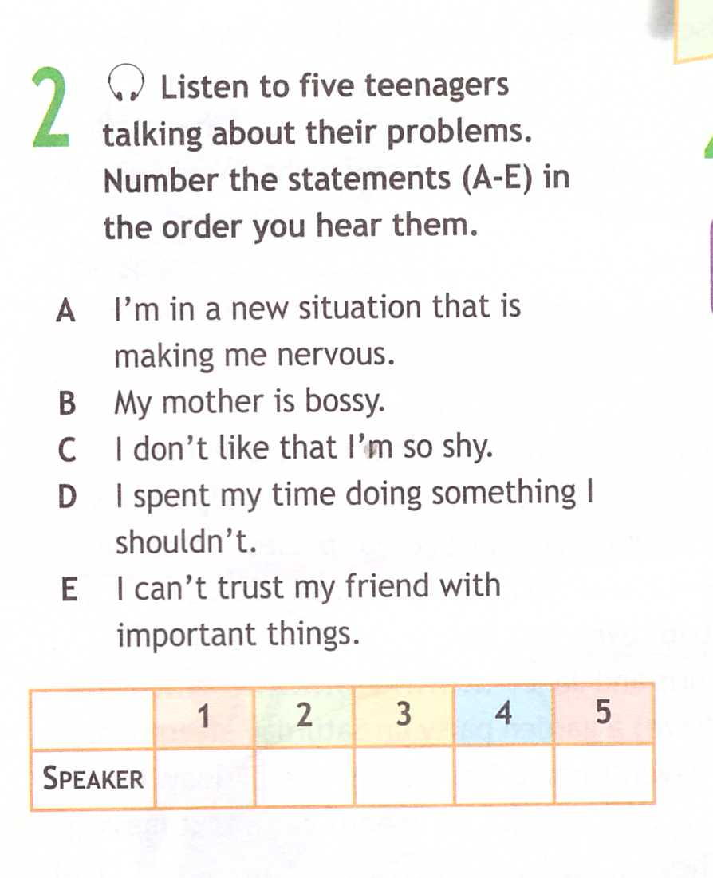

**“Group Work”**

We think this person is…

To our minds this person is …

_______________________________________________________________________________________________________________________________________________________________________________________________________________________________________________________________________________________________________________________________________________________

**“Listening”**

